Wheel and Axle Notes

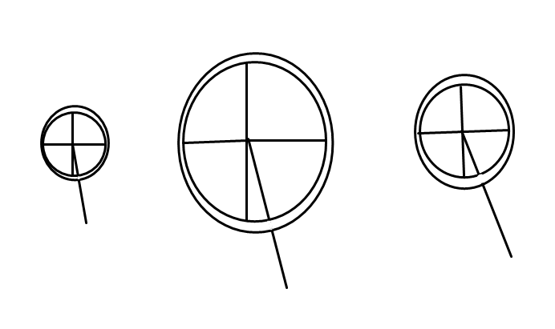
- The LARGER the wheel the EASIER it will be to move the load.

- The parts of the wheel.
Crank
Axle
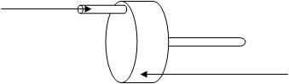
Force
Wheel

- ROLLERS are a type of wheel that can be used to move heavy objects.
