Name_______________________________ Date:_______________

Inclined Plane and Wedges Review

arrow tip 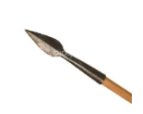 INCLINED PLANE or WEDGE or NEITHER
ramp 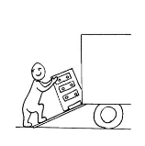 INCLINED PLANE or WEDGE or NEITHER
a table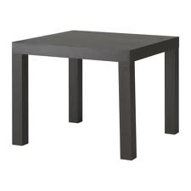 INCLINED PLANE or WEDGE or NEITHER

2. Circle examples of Inclined Planes and Wedges. (5 pts)

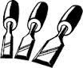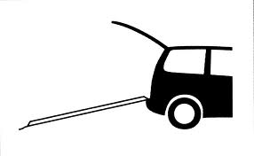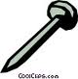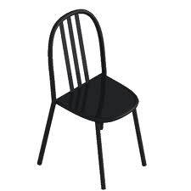

3. Circle the inclined plane that makes this job the EASIEST (1 pt)

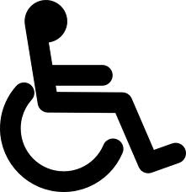

4. Explain WHY. Make sure to include force, load, distance, and work. (3 pts)

The inclined plane with the longer distance will help the person in the wheelchair use less force. The load is the person in the wheelchair and the work is getting to the top of the ramp.

5. Circle the WEDGE will make this job the EASIEST.

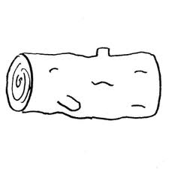

6. Explain WHY. Make sure to include force, work, load and distance.

The distance of the wedge helps make the work easier. It helps us use less force to split the load.

