LESSON
2-10
Study Guide
Part A
Unit

Fill in the unit box and the blanks.

- 5 + _______ = 13 2. 16 = 9 + ______
50 + _______ = 130 160 = 9 + ______
500 + _______ = 1,300 1,600 = 9 + _______
Complete the tables. Write your own number pair in the last row of each table.

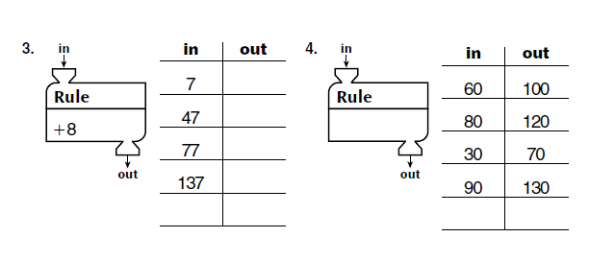
110
80
50
20
100
70
80
50
145
65
35
5
+ 6

5. Use 3 of the cards below to write a name for the target number.
Remember to write each step separately.
target
number
7
5
3
2
4
8

________________________________________________________________________________________________________________________________________________________________________________________________________________________________________________________________________
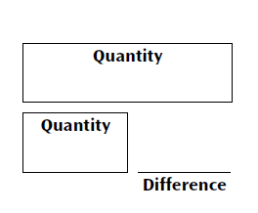
Solve the following number stories. Use the diagrams or pictures to help you.

6. One turtle nest has 42 eggs.
Another turtle nest has 18 eggs.
How many more eggs are in the first nest?

Answer the question: ____________________
(unit)

Number model: ______________________________________________
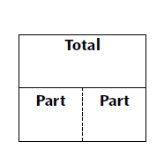

7. Meredith ran for 30 minutes on Friday
and 27 minutes on Saturday. How many
minutes in all did Meredith run?

Answer the question: _____________________
(unit)

Number model: ________________________________________________

Draw the hands to show the time.

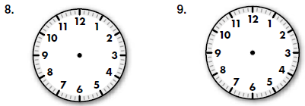
2:35
5:10

10. In the number 6,259

the 2 means ___________
the 9 means ___________
the 5 means ___________
the 6 means ___________

______________________________
Part B

Complete the tables. Write your own number pair in the last row.

11.

12.

500

1,300
200
600
700
1,100
47

67

- 8
37

15

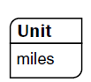
Write a number model for your ballpark estimate.
Use your favorite method to solve each problem.
Show your work.

13. Ballpark estimate: 14. Ballpark estimate:

__________________________ ______________________

375 831
+ 249 - 748

A Football Sunday Dinner
Open Response
LESSON
2-10

Mrs. Reid is cooking a 16 – pound turkey for the Eagles game this Sunday. The turkey must bake about 15 minutes for every pound.

For how long does the turkey need to bake? ________ hours ________ minutes

Show all of your work. Write and explanation of how you solved the problem.

